Manage Pending Payments

A situation may arise when you will want to be able to view all pending payments for a member so you can assist with any necessary payment research or challenges.

This tool can also be used if an account is closed and pending payments need to be cancelled.

# Manage pending payments using the CBP admin tool

1. Open and login to the Connect BillPay Admin
2. Within the admin, navigate to Bill Pay on the lefthand side
3. Under Other Tools, click on Manage Pending Payments
4. You will see the following:  
   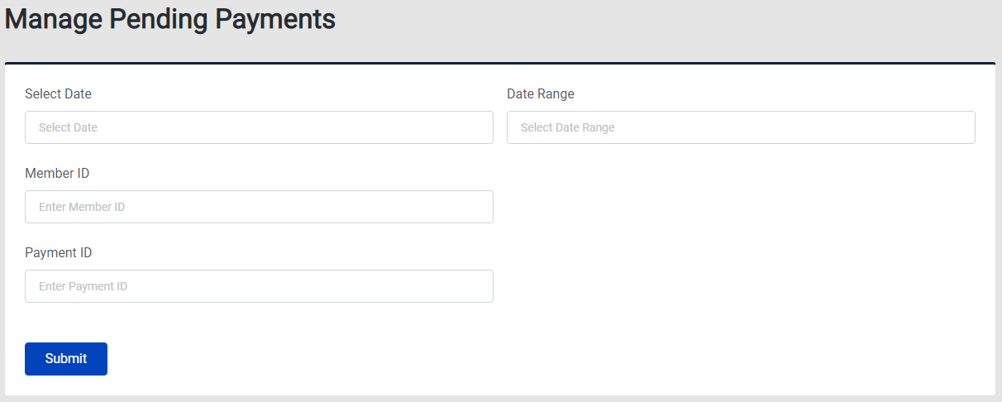
5. Enter the desired search criteria and click submit
6. A list of results will display below
7. Select a specific payment and a details page will appear on the righthand side:  
   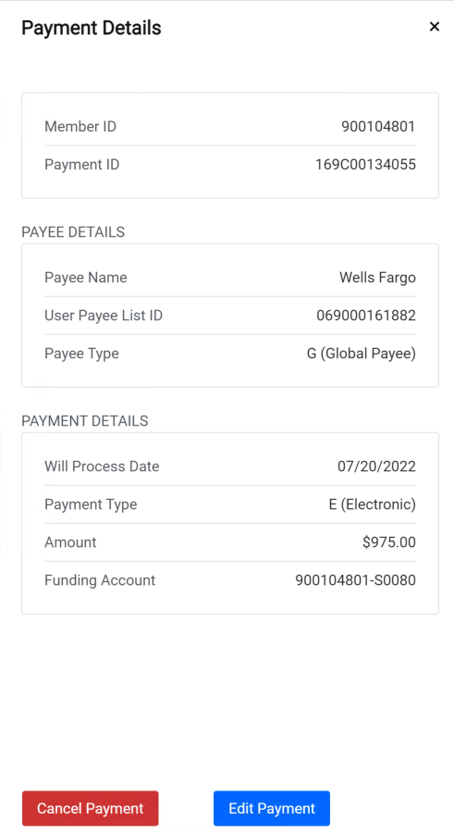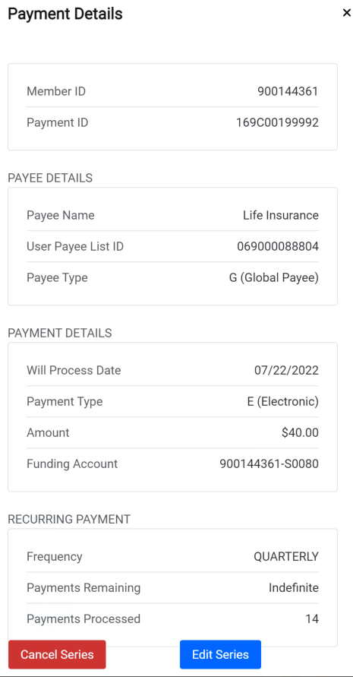
8. If you click ‘Cancel Payment’ or ‘Cancel Series’, a confirmation box will appear:  
   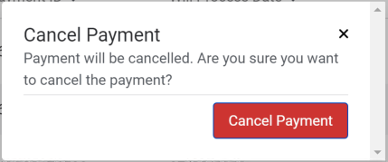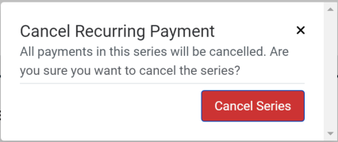  
   Confirming cancellation will cause the member’s payment to not be processed. In the case of recurring payments, if you cancel the series, all future payments will be cancelled.   
   This cannot be undone.
9. If you click ‘Edit Payment’, a separate box will appear with editable fields:   
   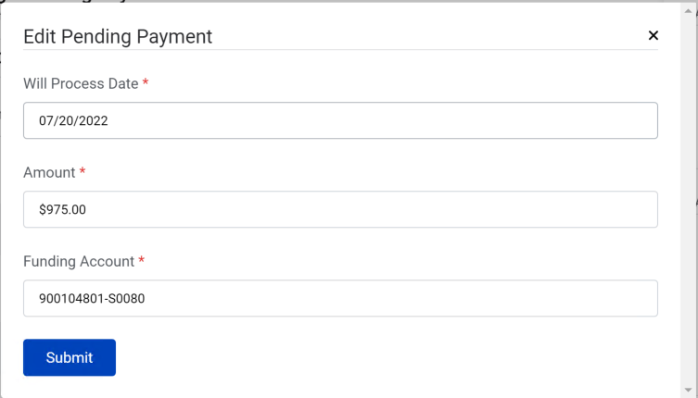  
   Clicking ‘Submit’ will confirm all changes for the individual payment or recurring series.